**Project 4:**

**Working with Elastic IP's**

Step 1: Create a Linux AMI: Amazon Linux 2 AMI (HVM), SSD Volume Type

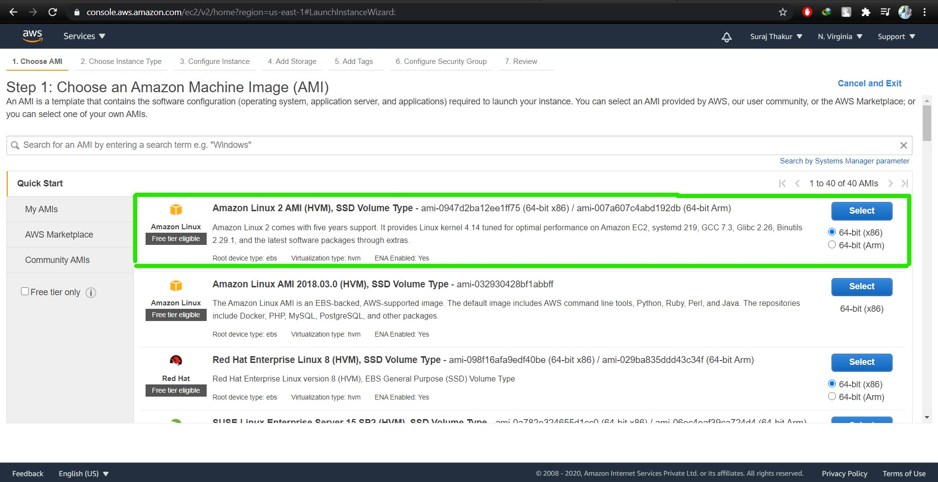

Step 2: Switch to the root user using following command:

sudo –s

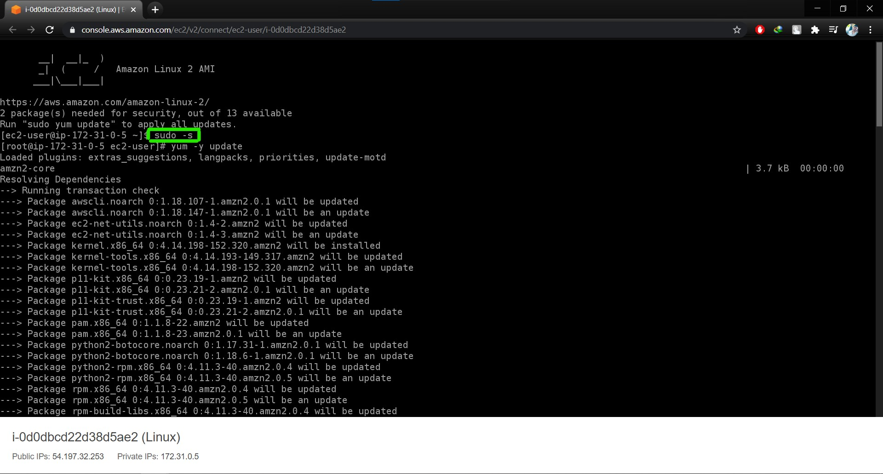

Step 3: Now run the updates using the following command:

yum -y update

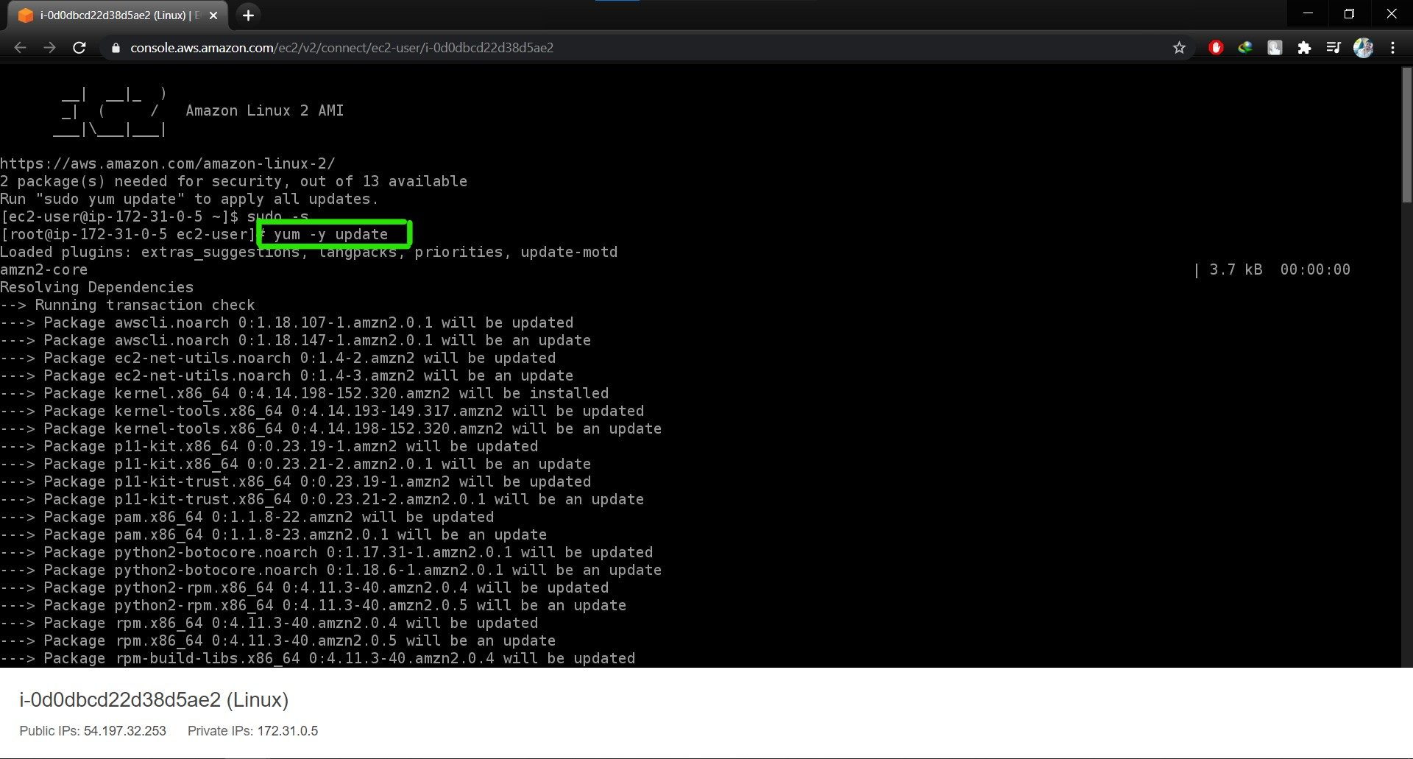

Step 4: Once completed, let’s install and run an apache server.

Install the Apache webserver:

yum install httpd

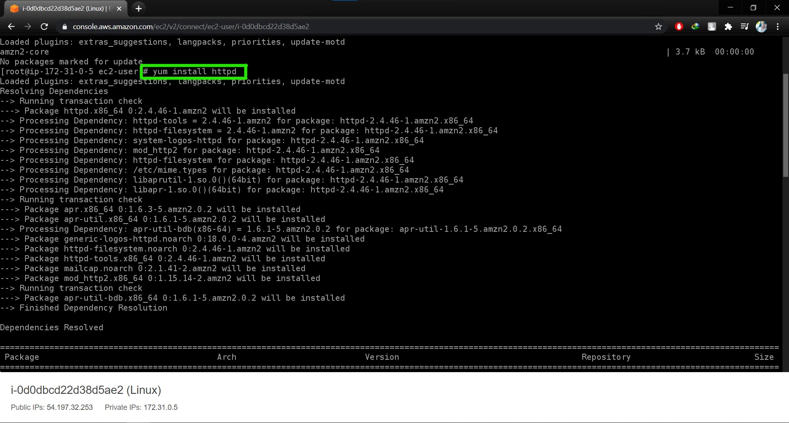

Step 5: Start the webserver using the following command:

systemctl start httpd

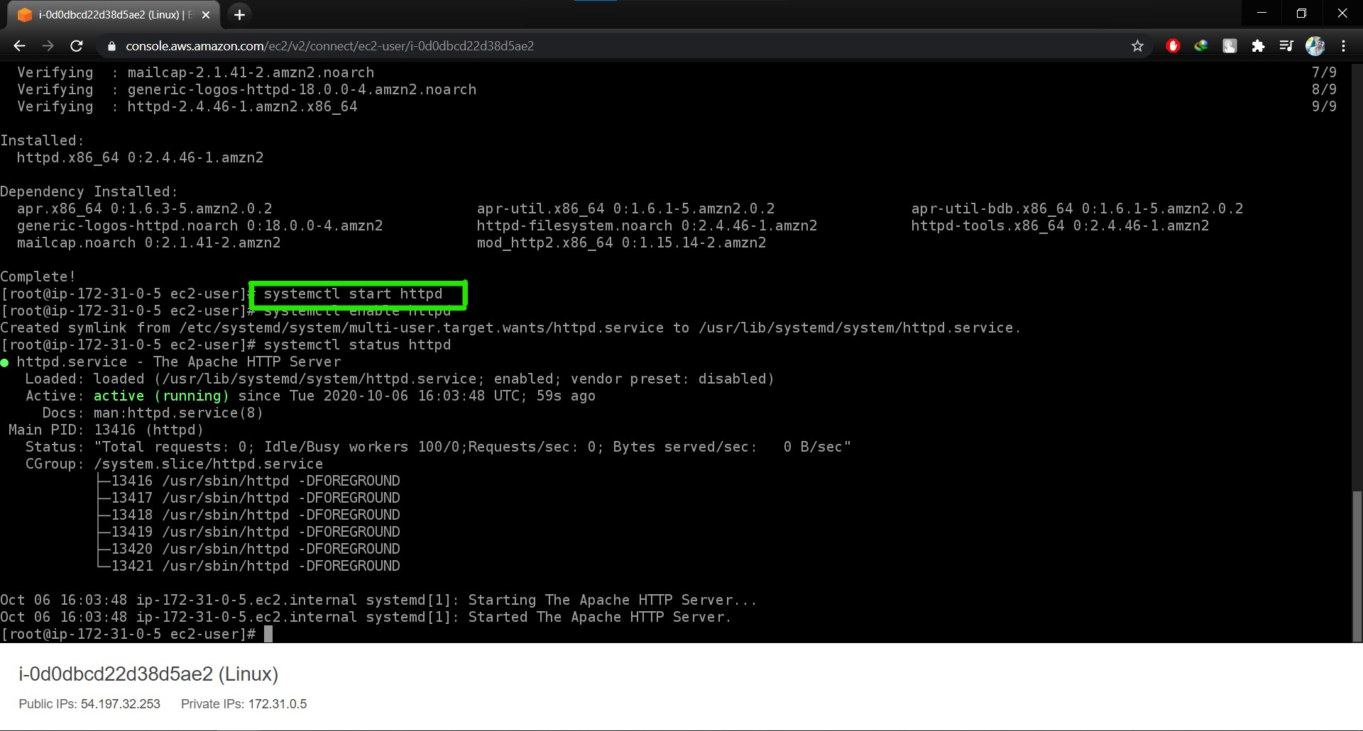

Step 6: Now enable httpd using the following command:

systemctl enable httpd

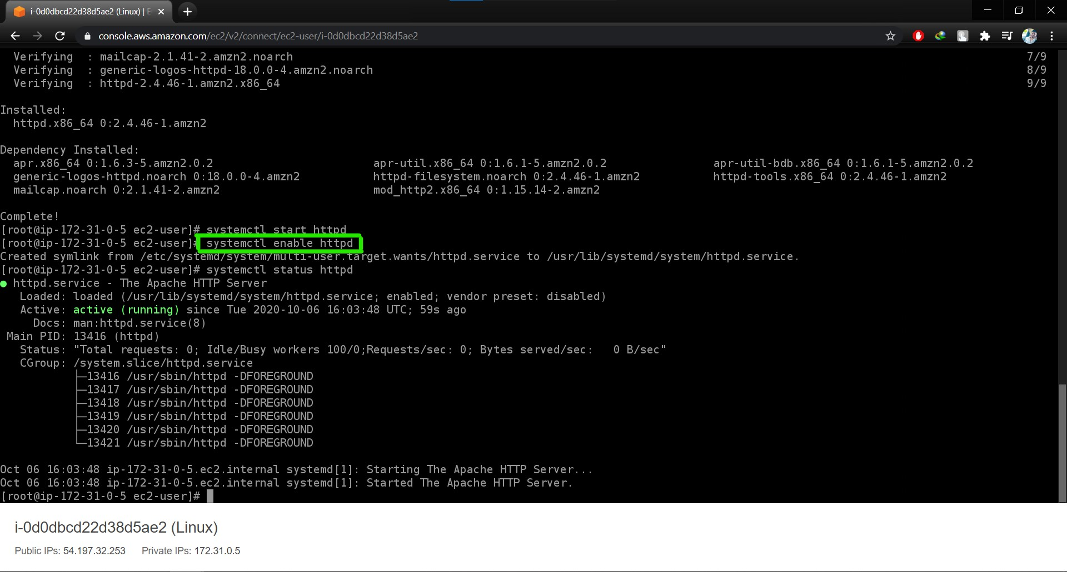

Step 7: Check the web server status

systemctl status httpd

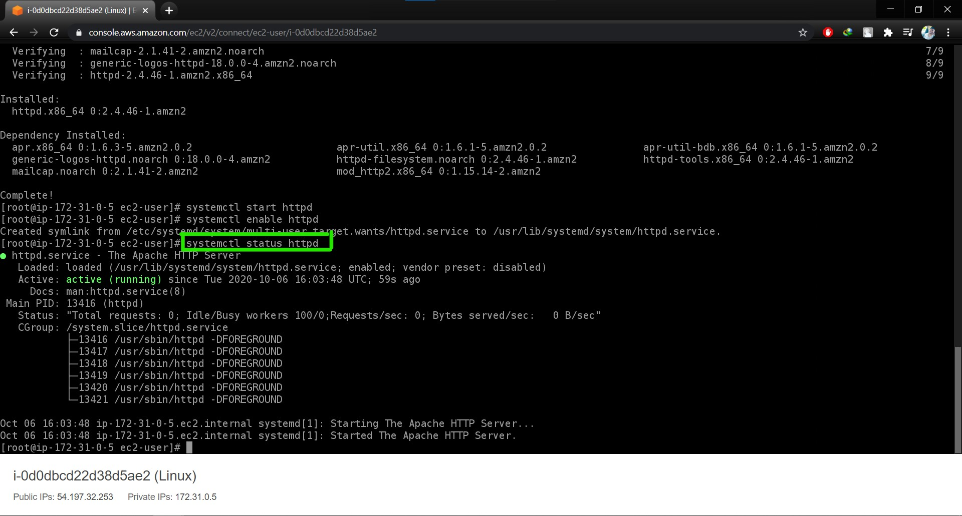

You can see the active status is running.

You can test that your web server is properly installed and started by entering the public IP address of your EC2 instance in the address bar of a web browser.

